分析报告Certificate of Analysis
产品名称Product Name | 红景天提取物Rhodiola Rosea Extract
拉丁名称Latin Name | Rhodiola crenulata (HK. f. et Thoms.) H. Ohba
生产批号Batch No. | TBR180817 | 生产日期 Manufacturing Date | 2018-08-17
生产批量Butch Quantity | 500kg | 报告日期Date of Certificate | 2018-08-21

检测项目Items | 检测标准Specifications | 检测结果Results
红景天甙含量Salidroside Content | ≥3.00% | 3.21%
检测方法Test Method | 高效液相色谱HPLC | 符合Conforms
提取部位Part Used | 根部Root | 符合Conforms
提取溶剂Extraction Solvent | 乙醇和水Ethanol&Water | 符合Conforms
性状检查Organoleptic
外观Appearance | 精细粉末Fine Powder | 符合Conforms
颜色Color | 棕黄色 Brown Yellow | 符合Conforms
气味Odor | 特殊Characteristic | 符合Conforms
味道Taste | 特殊Characteristic | 符合Conforms
物理性状Physical Charactristics
粒径Partical Size | 100%通过80目 100%Through 80 Mesh | 符合Conforms
干燥失重Loss on Drying | ≤5.0% | 3.28%
灰分Ash Content | ≤5.0% | 3.15%
堆积密度 Bulk Density | 50-60g/100ml | 符合Conforms
农药残留Pesticide Residue | 未检出Negative | 未检出Negative
重金属Heavy Metals
总量Total Heavy Metals | ≤10ppm | 符合Conforms
砷As | ≤1ppm | 符合Conforms
铅Pb | ≤3ppm | 符合Conforms
微生物检测Microbiological Tests
菌落总数Total Plate Count | ≤5000cfu/g | 符合Conforms
酵母菌及霉菌Total Yeast & Mold | ≤500cfu/g | 符合Conforms
大肠杆菌E.Coli. | 未检出Negative | 未检出Negative
沙门氏菌Salmonelia | 未检出Negative | 未检出Negative
葡萄球菌Staphylococcus | 未检出Negative | 未检出Negative

结论Conclusion | 符合检测标准Conform to specification.
保存方法Storage | 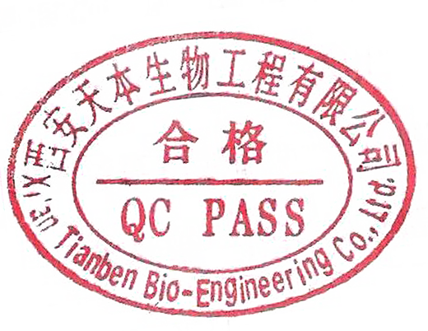  放置于干燥通风处，避免太阳和高温照射Store in a cool and dry place, keep away from direct strong and heat.
保质期Shelf Life | 密封保存两年Two years if sealed and store away from direct sun light.
检验人Analyst: 刘丹 复核人Corrector: 张金平 负责人Quality Assurance Officer: 张金平

